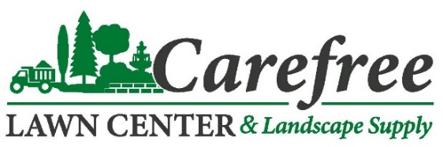  50# BAGS / PALLET | 50 LB BAGS  2020-2021 WINTER ROCKSALT & ICE MELT PRICING | EACH | PALLET  PRICING | OPEN 24 HOURS DURING WINTER WEATHER EVENTS!  TEXT “EZSALT”  TO 474747  TO BE ADDED TO OUR ALERT LIST  (BLUE) BULK SALT  $80 PER CUBIC YARD
ROCKSALT  49 BAGS/PALLET | MELTS SNOW AND ICE WHILE PROVIDING TRACTION  IDEAL SIZE FOR SPREADING | $6.25 | $5.25  ($257.25) | 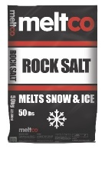
MELTCO TREATED  49 BAGS/PALLET | EFFECTIVE TO -5°  (BLUE COLOR INDICATOR)  SODIUM, MAGNESIUM & MCI3 | $7.75 | $6.95  ($340.55) | 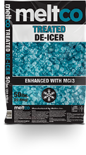
MELTCO PREMIUM  49 BAGS/PALLET | EFFECTIVE TO -22°  CMA & MCI3 (GREEN COLOR INDICATOR)  SODIUM, MAGNESIUM, POTASIUM | $8.75 | $7.95  ($389.55) | 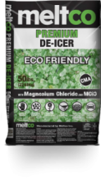
MELTCO COMMERCIAL  49 BAGS/PALLET | EFFECTIVE TO -25°  CMA & MCI3 (ORANGE COLOR INDICATOR)  SODIUM, CALCIUM, POTASIUM | $8.75 | $7.95  ($389.55) | 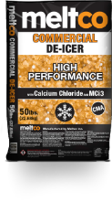
MELTCO LAKE EFFECT  49 BAGS/PALLET | EFFECTIVE TO -15° (PURPLE COLOR INDICATOR)  SODIUM, MAGNESIUM, CALCIUM CHLORIDE | $7.95 | $7.25  ($355.25) | 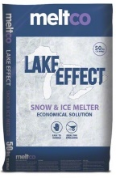
DRAGON MELT  56 BAGS/PALLET | EFFECTIVE TO -12° (GREEN)  SODIUM CHLORIDE, MAGNESIUM CHLORIDE | $7.95 | $6.75  ($400.40) | 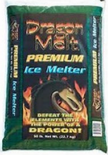
ICINATOR PREMIUM  50 BAGS/PALLET | EFFECTIVE TO -22° (BLUE)  SODIUM, MAGNESIUM, CALCIUM CHLORIDE | $7.75 | $6.75  ($337.50)
PELDOW  55 BAGS/PALLET | EFFECTIVE TO -25° (PELLETS)  CALCIUM CHLORIDE | $13.95 | $13.50  ($742.50 | 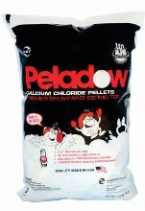
MAGNESIUM  48 BAGS/PALLET | EFFECTIVE TO -13° (PELLETS)  MAGNESIUM CHLORIDE | $14.95 | $14.50  ($696) | 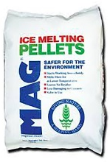
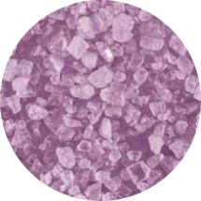
NOW
SUPPLYING
DRAGON MELT

OPEN 24 HOURS DURING WINTER WEATHER EVENTS!
TEXT “EZSALT”
TO 474747
TO BE ADDED TO OUR ALERT LIST

PRICES SUBJECT TO CHANGE. 10-01-20

